G3P配置方法截图：
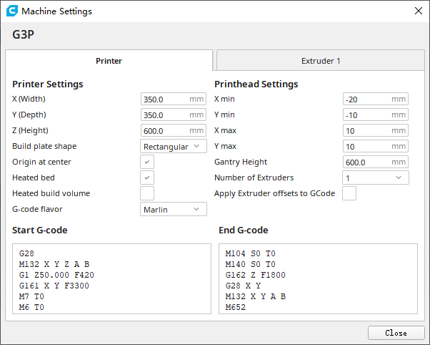
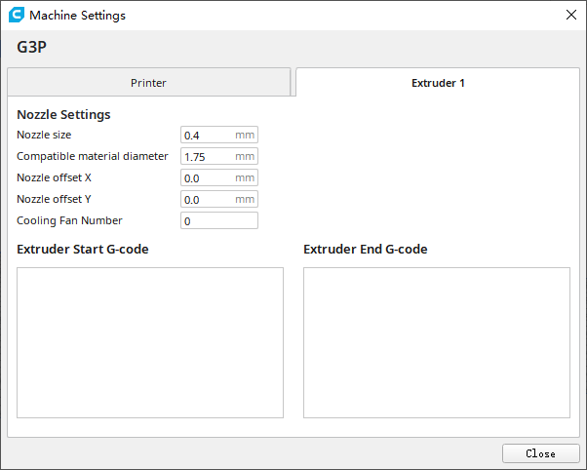
Start G-code：
G28
M132 X Y Z A B
G1 Z50.000 F420
G161 X Y F3300
M7 T0
M6 T0
M651 S255

End G-code：
M104 S0 T0
M140 S0 T0
G162 Z F1800
G28 X Y
M132 X Y A B
M652
G91
M18

