G3P Prusa
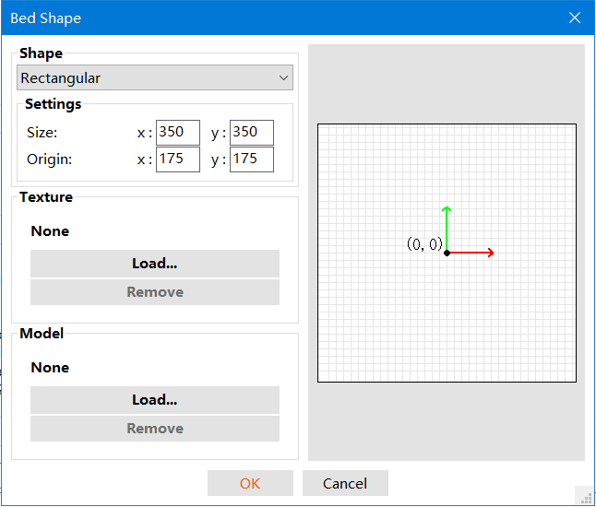
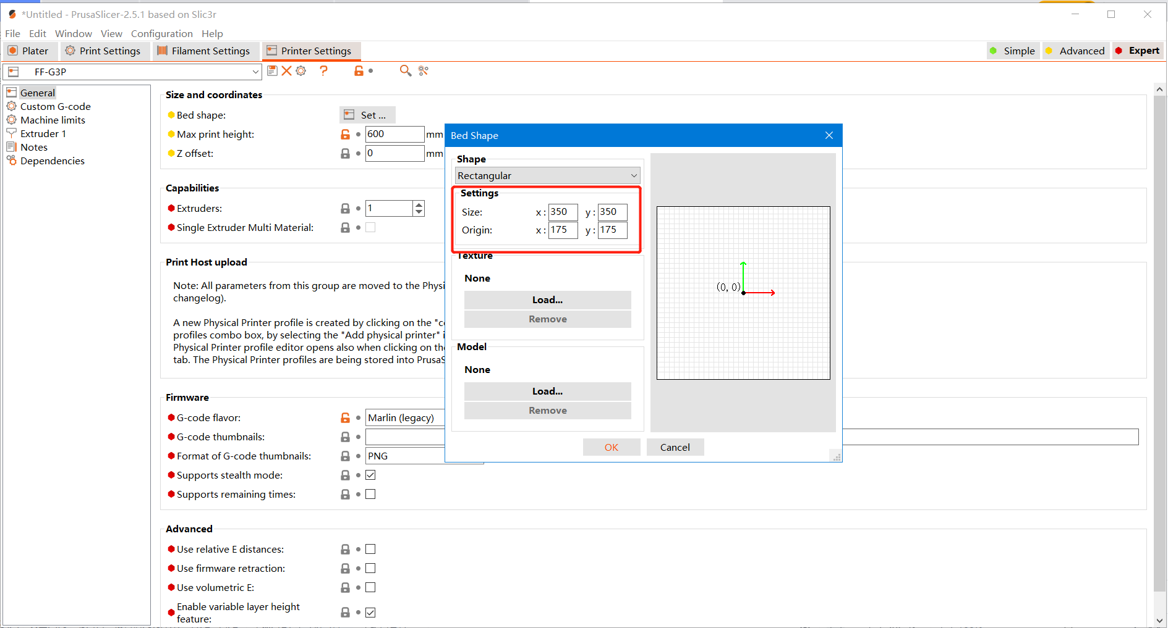
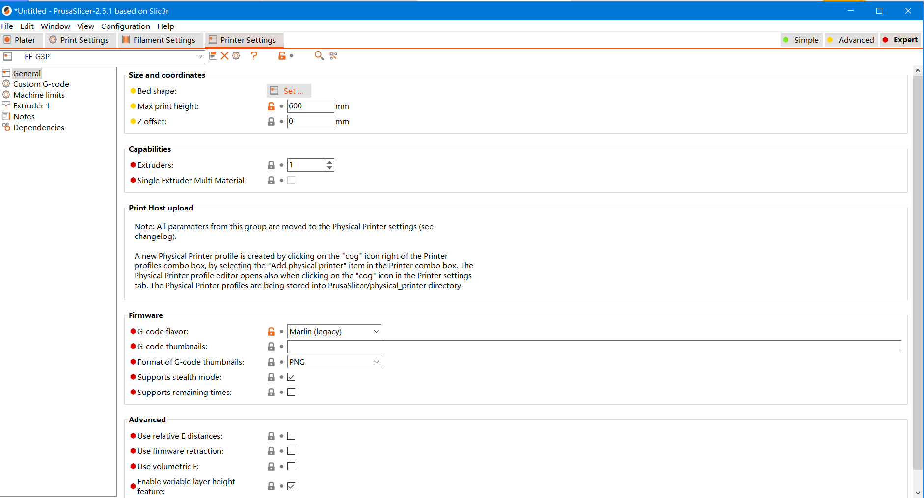

G-code配置
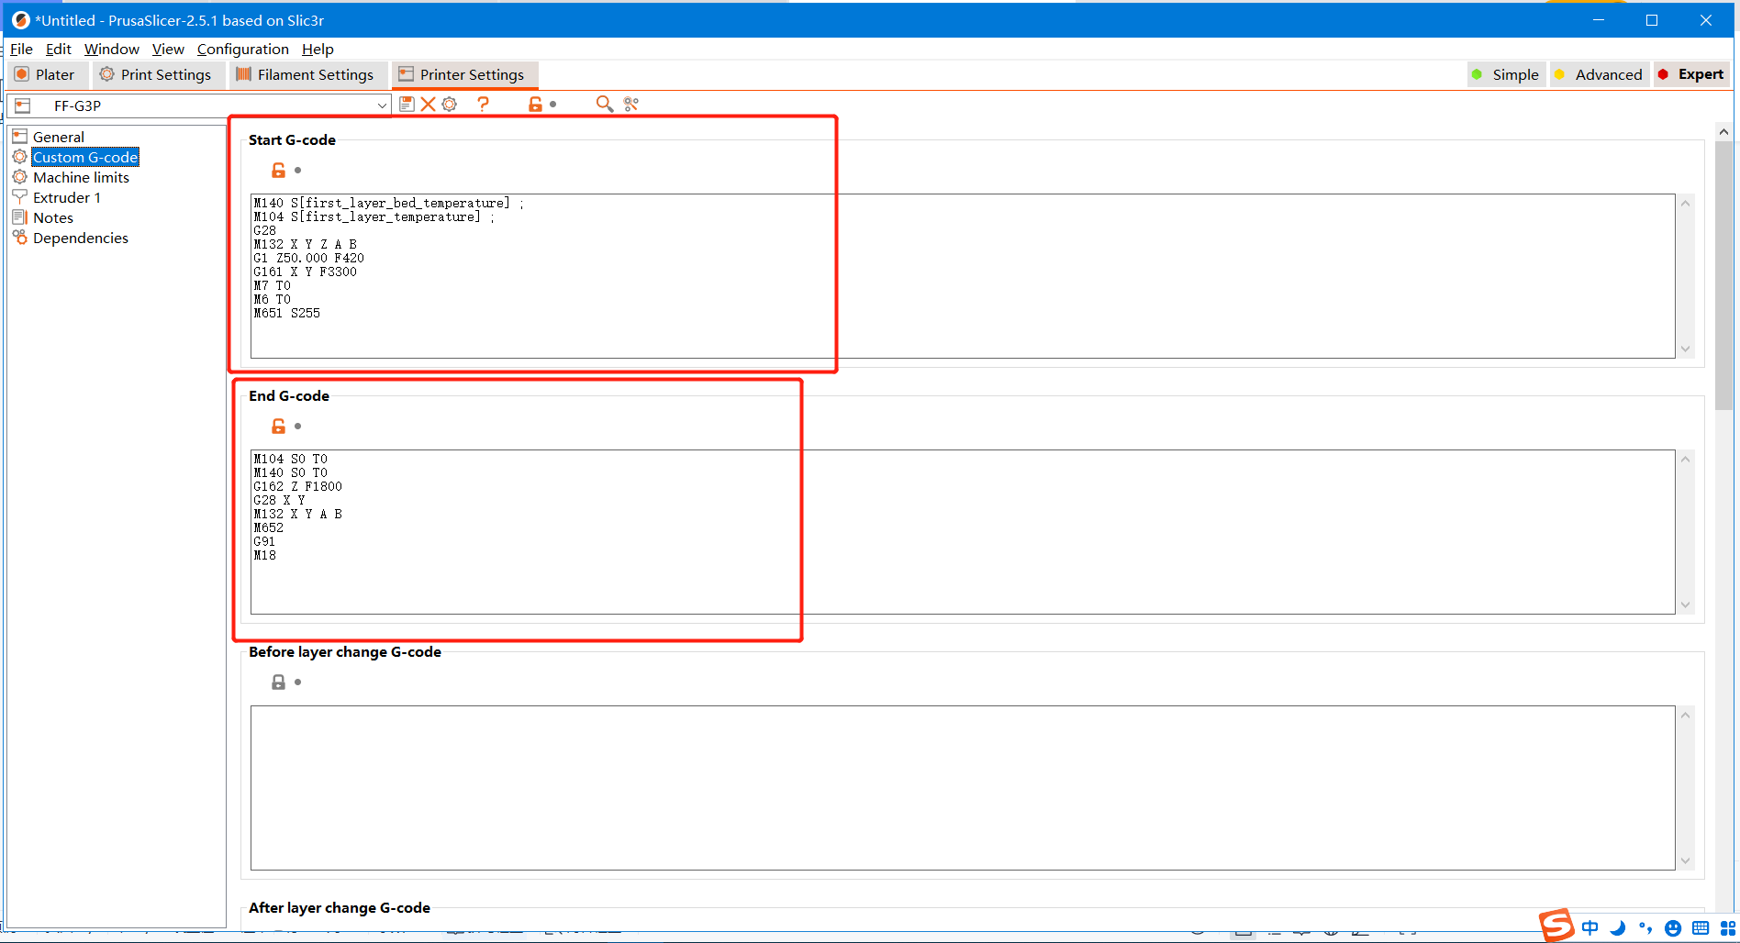
Start G-code：
M140 S[first_layer_bed_temperature] ;
M104 S[first_layer_temperature] ;
G28
M132 X Y Z A B
G1 Z50.000 F420
G161 X Y F3300
M7 T0
M6 T0
M651 S255

End G-code:
M104 S0 T0
M140 S0 T0
G162 Z F1800
G28 X Y
M132 X Y A B
M652
G91
M18

