**C4 Konfiguration für Cura：**

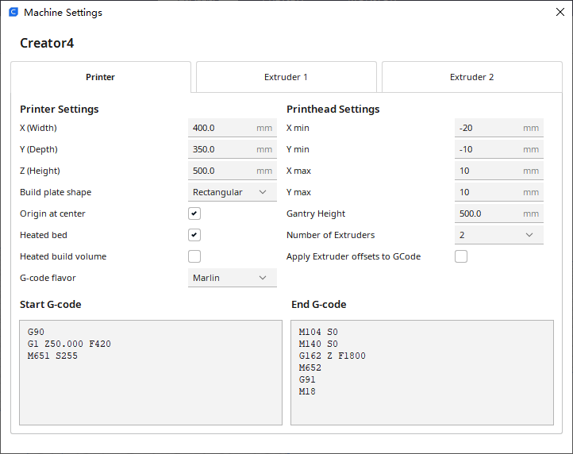

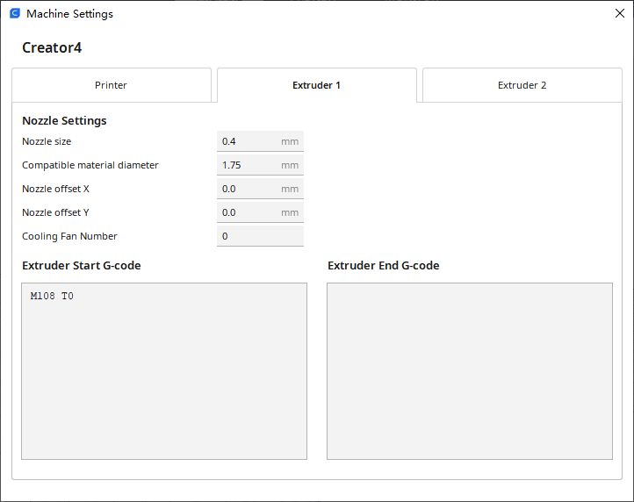

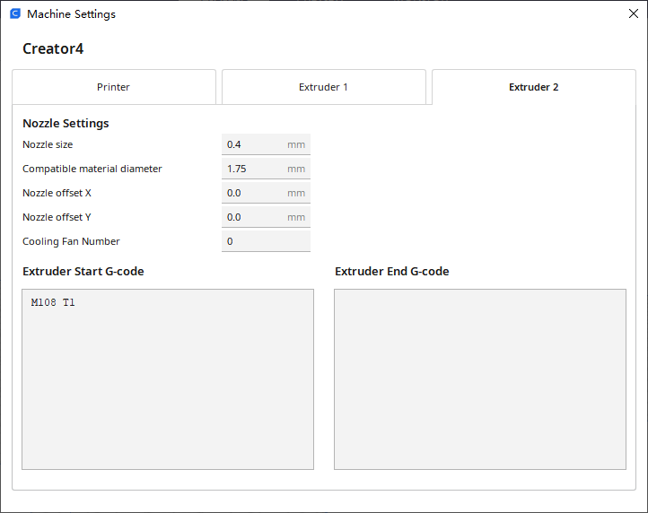

**Start G-code：**

G90

G1 Z50.000 F420

M651 S255

**End** **G-code：**

M104 S0

M140 S0

G162 Z F1800

M652

G91

M18

**Extruder** **1**

**Start G-code：**

M108 T0

**Extruder** **2**

**Start G-code：**

M108 T1

Note: extruder1--right extruder, extruder 2--left extruder. Chamber temperature couldn’t be set.